NO. | NAME OF THE BIDDER |  |  |  | TOTAL BID PRICE
1- | @V\®dm€m’m/ Mm Sw’HHH‘H‘EILxB fm/umom q |  |  |  | QLF‘IB "%’10 F20
2. | MULQHm .XHEG Sawmmg (14:1) Lm |  |  |  | Q 50 §QO “L70
3- | NDKa‘Ié? €I4é7/d6émricwn S’C—evmgg (VET) L713 |  |  |  | Q K‘W’ 319$ ~<1D
4. | DEL-7W gu/LT Emnmmaw ComM/WWTS P'Yj L733 |  |  |  | (2%} S’fég ~ 3%
5. | M'SUKU Effvlmwmé#7m. CONJULTIr/a aw} L'm |  |  |  | mgo 0cm w QED.
6. | / |  |  |  | /
7 | / |  |  |  | /
8. | / |  |  |  | /
9. | WA / |  |  |  | /
Vb L,
J. ................
Signature ........................................... |  | . | .



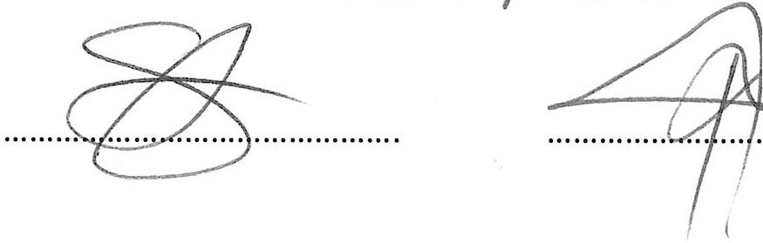
GREATER GIYANI MUNICIPALITY
TENDER OPENING REGISTER
TENDER NAME: APPOINTMENT OF AN INDEPENDENT QUALIFIED SERVICE PROVIDER TO CONDUCT ANNUAL EXTERNAL AUDIT IN
THE WASTE MANAGEMENT FACILITIES FOR THE PERIOD OF 36 MONTHS TO BE APPOINTED ON AS AND WHEN REQUIRED
TENDER NUMBER: CONTRACT NUMBER: GIG/MI6707I007I2024
DATE: 05 SEPTEMBER 2024 TIME: 12H00

